**GoldRush**

**Rules**

Victor GANTER – 2926840

Melchior GARRIGUES – 2927207

Valentin FEREY – 2926392

Galdan MOULINNEUF – 2927686

COMPOSITION :

* 1x Board game
* 4x Dices of each colour
* Resources: 50x cards of each
* Units: 30 units of each type and each colour for each player

PREPARATION:

This game is designed for 2 to 4 players. Each players gets 6 of each resources at the beginning of the game. At this point, they can create units as they want.

Then, all players roll the dice to determine the order. The player with the highest number will be the first to place his units (he will create the unit with the resources he have), then the player on his left will follow until all resources are spend.

GAME:

In this game, there are workers which helps gain resources and units that help conquer the game.

There is three kind of units: cavalry, archery and infantry.

When the game starts, there is two win-conditions:

* Conquer all territories;
* Get 30 gold first

A player is out of the game when he no longer owns any territories.

One Turn consist of 4 steps, in each steps all players play each after another, the 4 steps are:

* Gather resources and place workers
* Create units with the resources
* Fights With other players
* Move units

*Resources & workers:*

For each territory the player control, the player gain 1 resource (accordingly to the territory resource type), EXCEPT gold, who can be only be obtain with workers.

The number of workers is set to 3. You can place your workers anywhere in the map (workers are virtual units), you cannot place a worker on a gold territory that you don’t control. To get resources you have to roll the dice for each worker.

When you roll the dice on a territory:

1: No resources on that territory;

2 – 5: 1x resource of the type you’re in;

6: 2x resources of the type you’re in;

*Create units:*

Then you can create as much units as you want if you have enough resources for it and you place it on one of your territories anywhere on the map.

Here is a table to recapitulate how to create each:

|  |  |  |  |
| --- | --- | --- | --- |
|  | Wood | Food | Iron |
| Cavalry | 0 | 2 | 1 |
| Archery | 2 | 1 | 0 |
| Infantry | 1 | 0 | 2 |

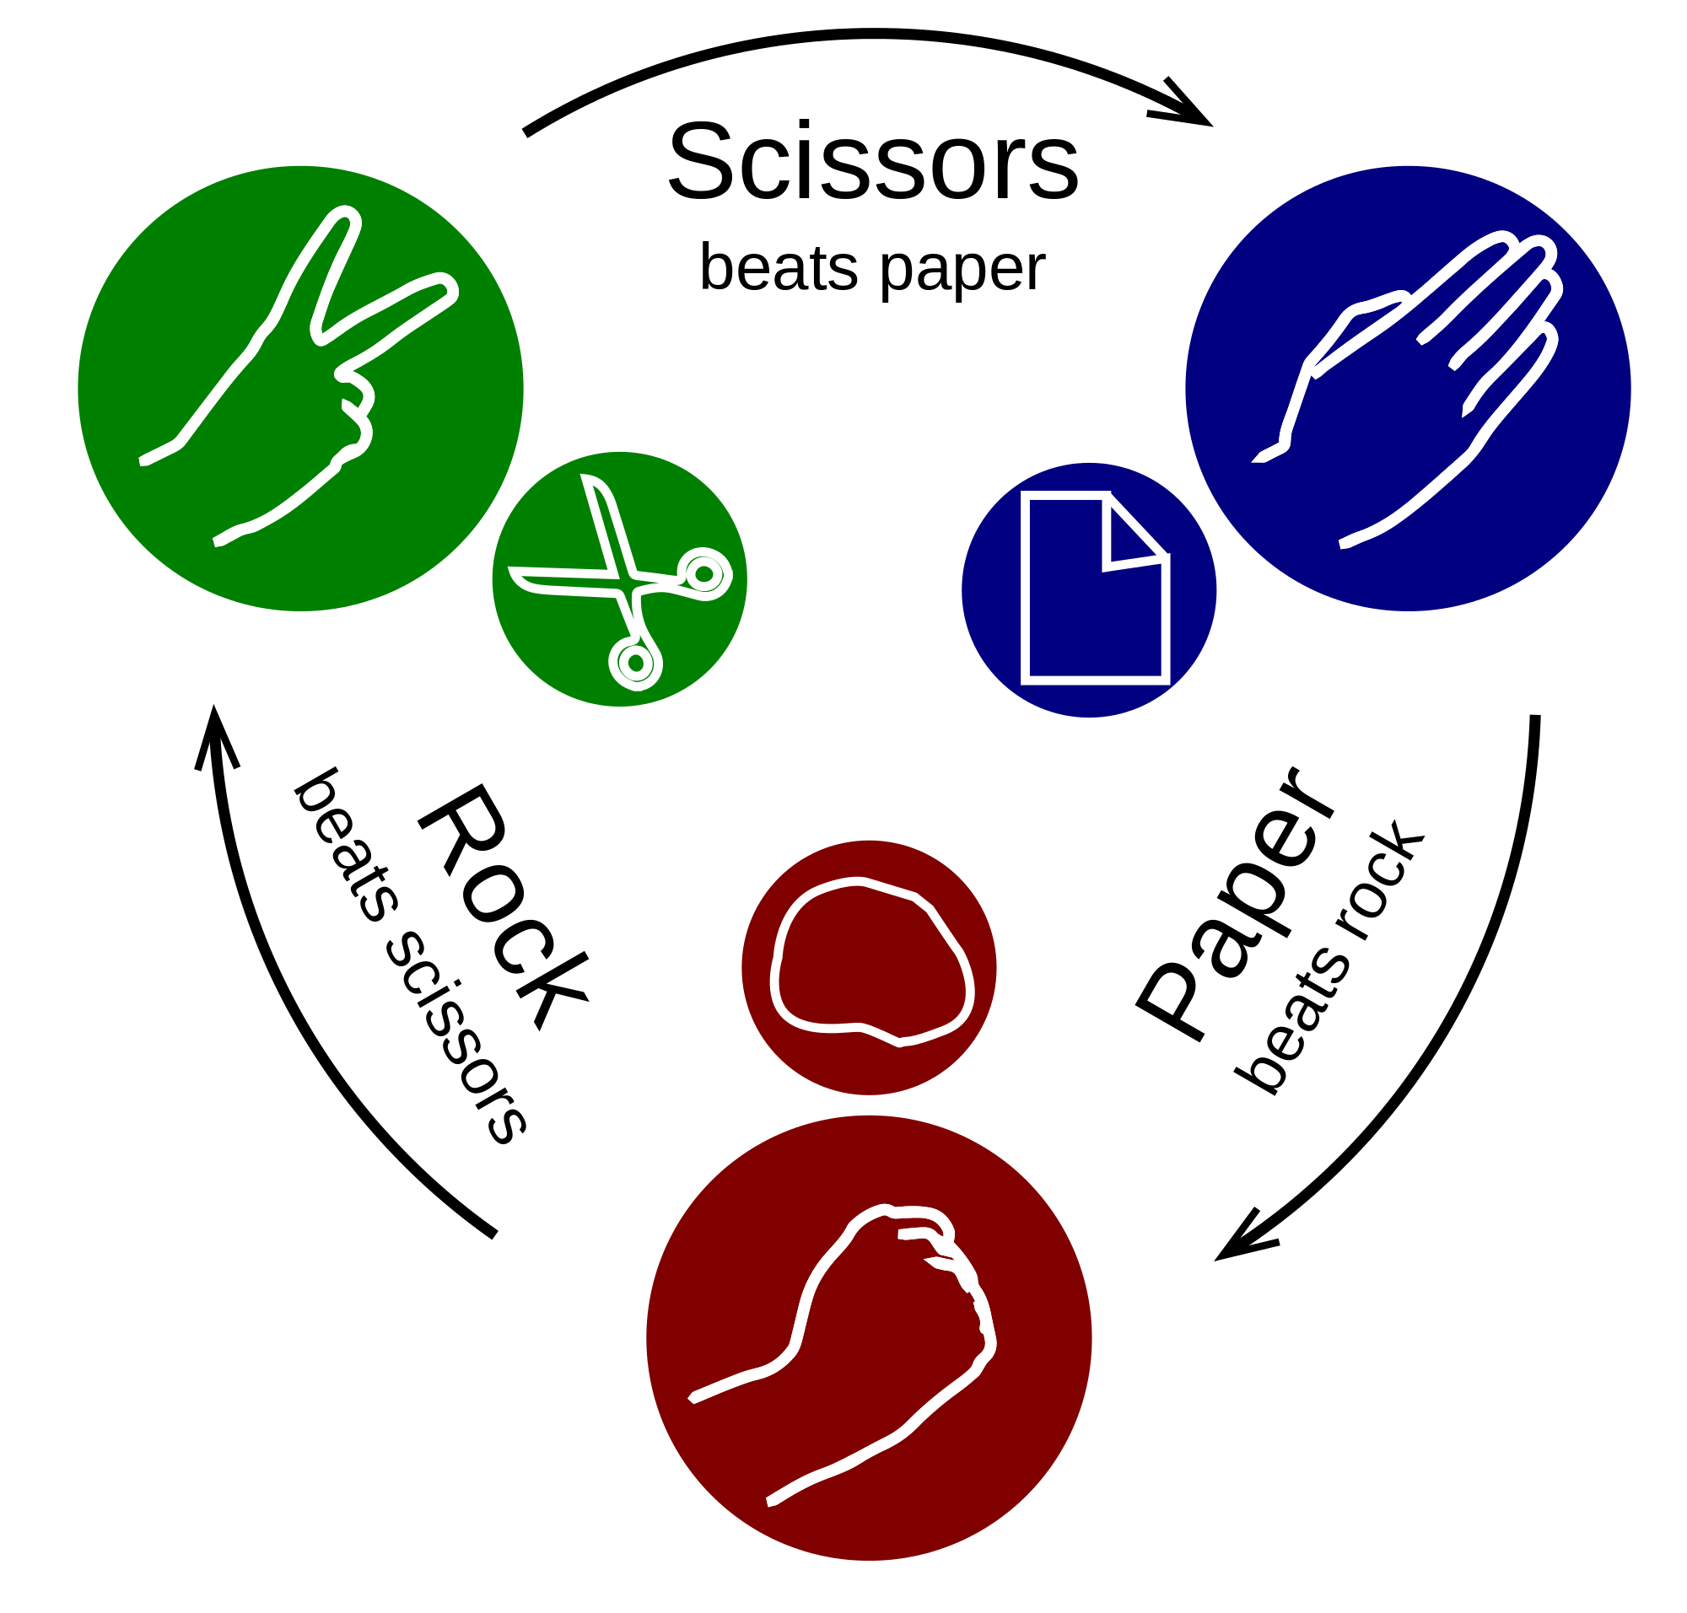

*Fights:*

It’s the same principle of the game *“Rock Paper Scissors”.*

We have three type of units, and these units can only counter one type of unit. Like here, for example the Paper can beat the rock, but he’s being defeated by the Scissors.

Cavalry -> Infantry -> Archery -> Cavalry.

Fights are turn-by-turn based, the defender will always begin. The player chose a unit to attack an enemy’s one. When two units of the same type are fighting, the fight results in a draw and both units will be destroyed. The player can choose to use 1 gold to increase the power of one unit for the turn.

If the whole fight results in a draw, the territory is left with no units but is still owned by the defender.

Your armies can only attack if they’re near enemy’s army, if they are further that one ground you can’t attack.

*Move units:*

You can move your units by one ground nearly. If a territory has no units it’s still controlled by the last player who have units on it.

**Map**

